5 Removing Elements

<https://www.youtube.com/watch?v=y17RuWkWdn8>

# Removing Elements with the querySelector

Here we have a <div> tag, inside of that <div> tag, we have a span, and each one of our spans have a different id name.

index.html

Go to the index.html

Write this <div> tag inside of the body

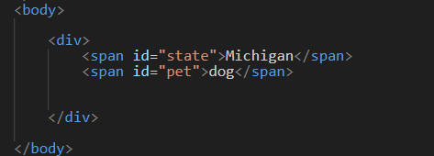

script.js

For this example, we will remove all of the code inside of the script file, except for the first line which sets the constant body to be attached to the body.

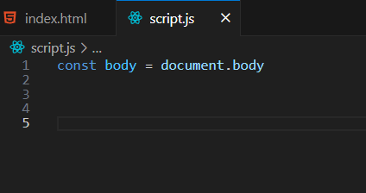

We usequerySelector is used to find and select a certain element. Here we are using the pound sign to grab the two spans that we created with the named ids.

Now write this Code.

